1. Computer Architecture
Computer architecture refers to the fundamental conceptual design or blueprint that describes the organizational and operational structure of a computer system, defining its functional behaviour and components like CPU, memory, I/O, buses, cores, pipelines etc and how they interact to execute instructions.

2. Central Processing Unit (CPU) & Cores
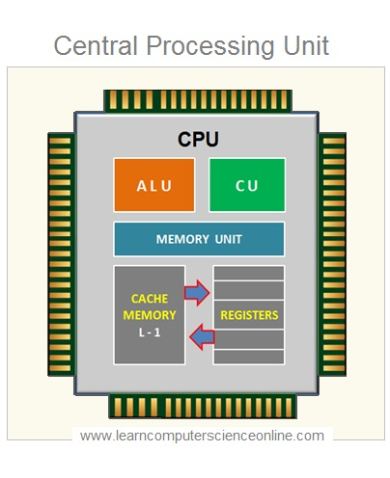
2.1 What is a CPU?
The CPU (Central Processing Unit) is the core processing component of a computer.
It performs fundamental operations like:
- Fetching instructions
- Decoding instructions
- Executing operations
- Managing data flow

2.2 CPU Components
- ALU (Arithmetic Logic Unit)
Handles arithmetic (add, multiply, etc.) and logical operations.
- Control Unit (CU)
Directs the processor's operations and coordinates other components.
- Registers
Very small, extremely fast memory used to store temporary data and addresses.

2.3 Clock Speed
Measured in GHz. Higher speed means more cycles per second, but real performance depends on cores, architecture, and cache.

3. Cores
3.1 What is a Core?
A core is an independent processing engine inside the CPU.
Examples:
- Dual-core: 2 tasks simultaneously
- Quad-core: 4 tasks
- 8/12/16+ cores: modern performance CPUs

Multiple cores improve multitasking, parallel computing, and performance in demanding workloads.

3.2 Threads
A thread is a sequence of instructions executed by a CPU.

4. RAM (Random Access Memory)

4.1 What is RAM?
RAM stores data that is actively being processed. It’s part of primary memory.
It is:
- Volatile in nature
- Much faster than secondary memory.
- Responsible for multitasking capability.

4.2 How RAM Works
1. Programs load into RAM
2. CPU accesses data from RAM
3. Closing programs frees memory

4.3 Types of RAM
- DDR4 / DDR5, LPDDR4X / LPDDR5, SRAM (used in cache), DRAM (standard RAM)

4.4 RAM Size & Effect
- 8 GB: Basic tasks
- 16 GB: Standard use
- 32–64 GB: Heavy workloads
- 128 GB+: Servers, AI

5. Cache Memory
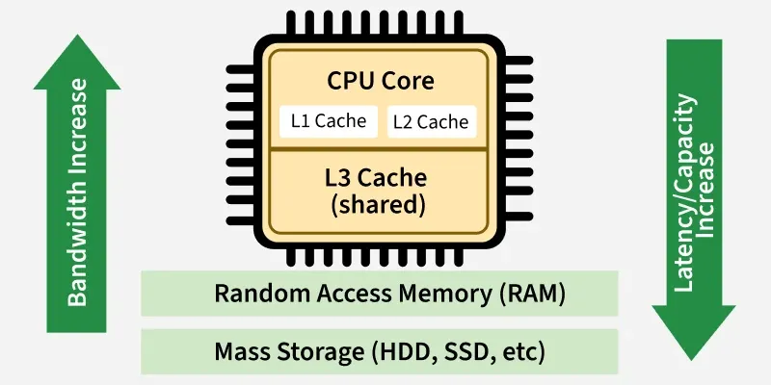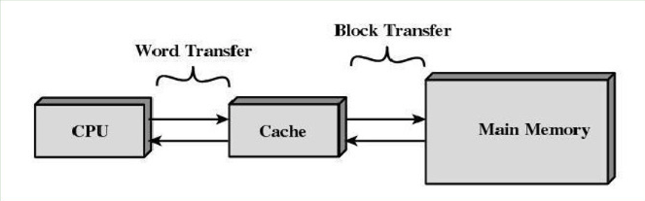

5.1 What is Cache?
Cache is high-speed memory built into the CPU.
It stores frequently accessed instructions and data.

5.2 Why Cache Is Needed
CPU is much faster than RAM.
Cache reduces latency and keeps the CPU busy instead of waiting for RAM.

5.3 Cache Levels
L1 Cache
Fastest and smallest (32–128 KB).
Closest to the core.

L2 Cache
Larger (256 KB–1 MB).
Slower than L1 but faster than RAM.

L3 Cache
Shared across all cores (4–64 MB).
Slower than L1/L2 but faster than RAM.

5.4 Cache Hit and Miss
Cache Hit: Data found → fast.
Cache Miss: Data fetched from RAM → slower.

